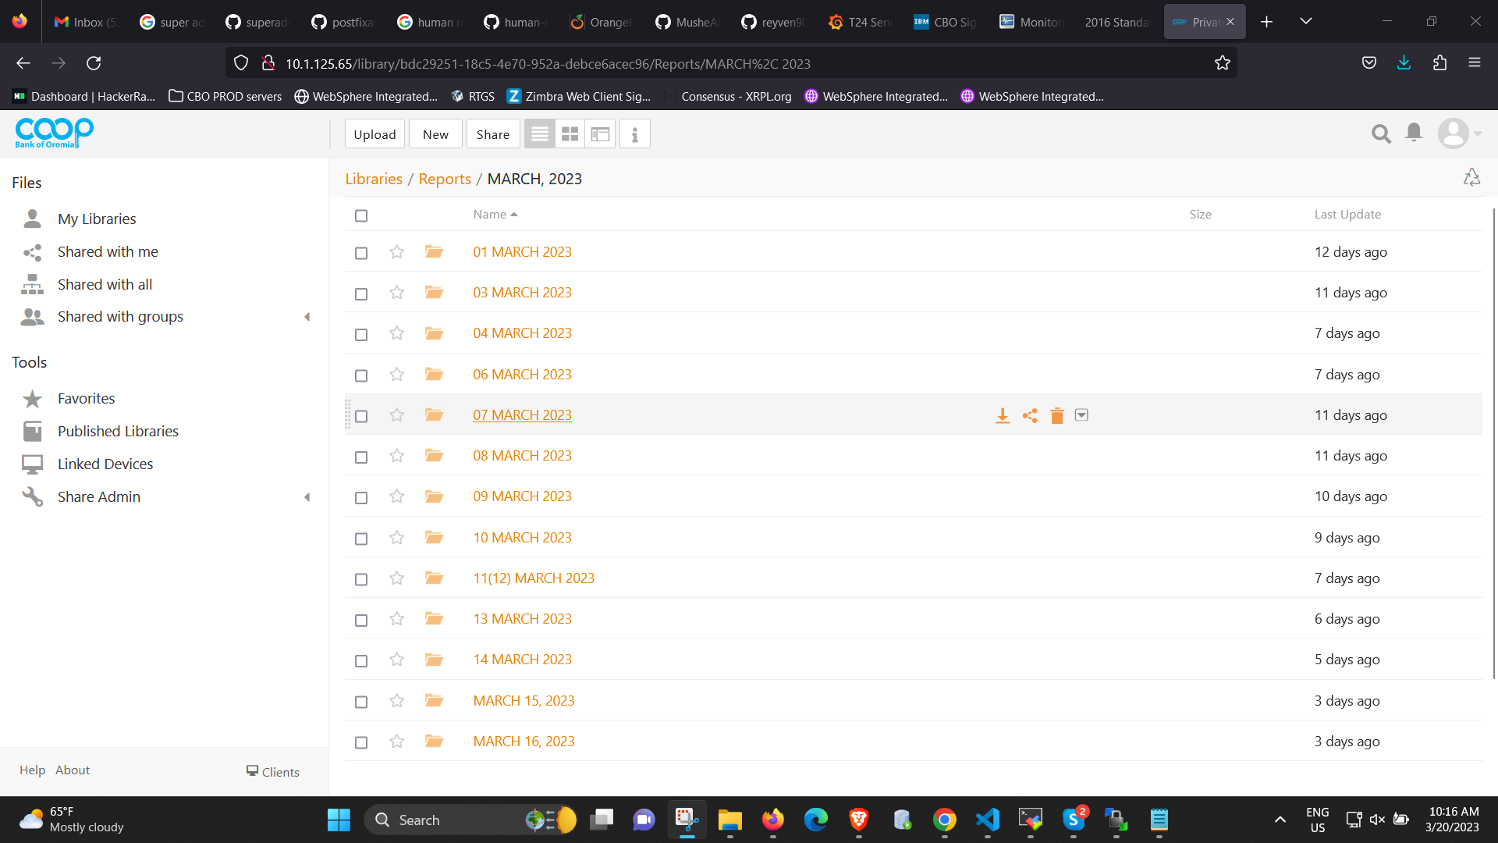

Then go to search icon on top right corner click on it

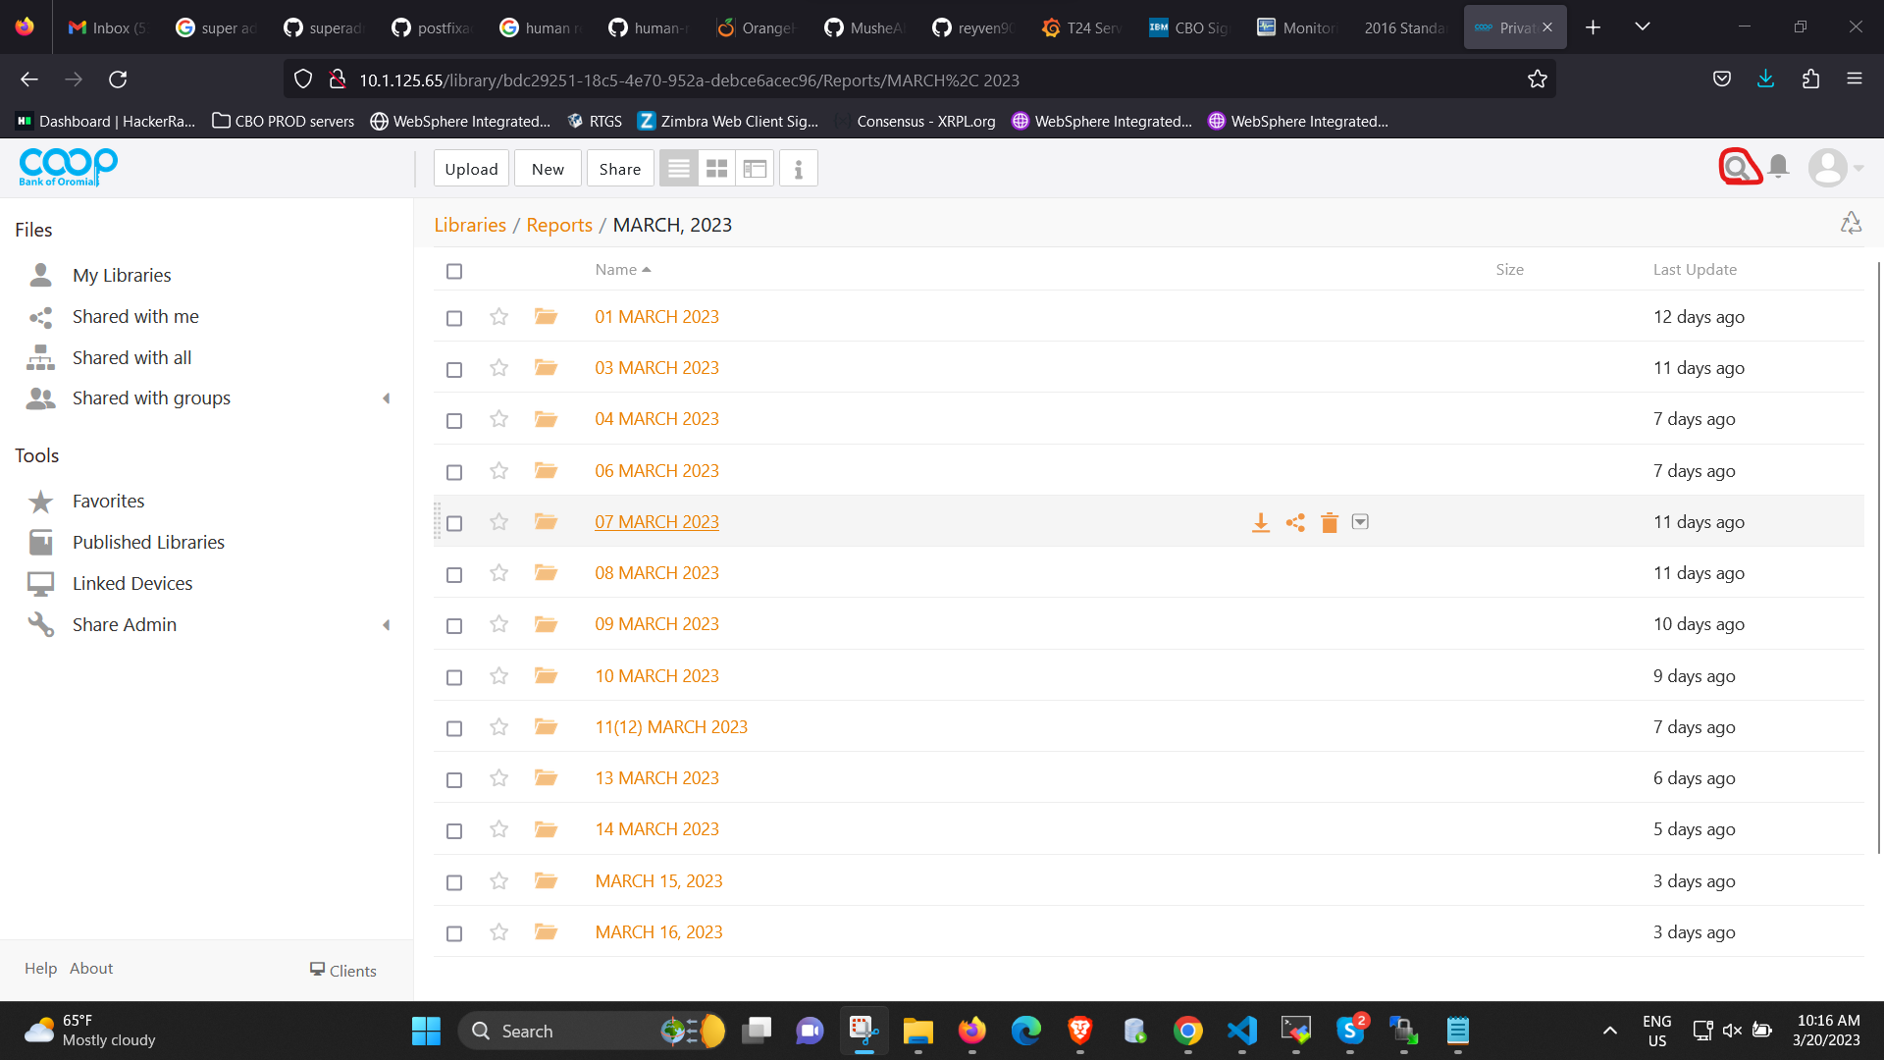

Then write CRC, CRB, CRF on search box provided

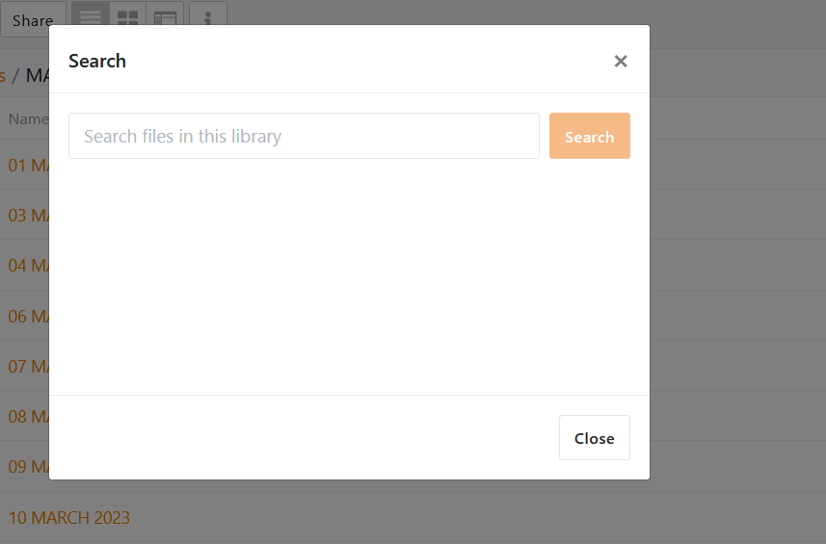

Then search CRB, CRC, CRF report for the company you need

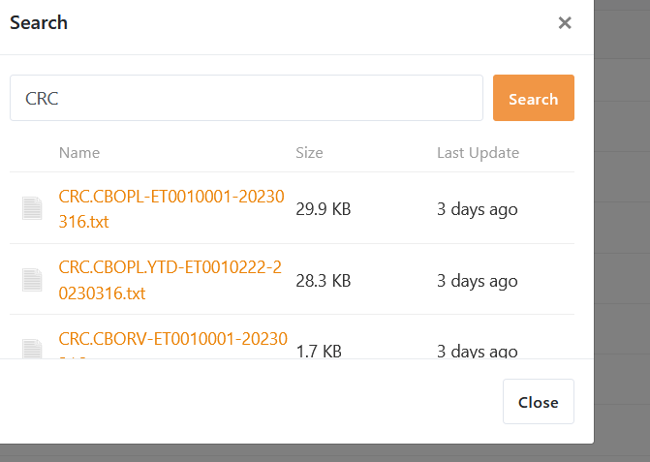

Finally click on the company you need (E.g. mekele)

